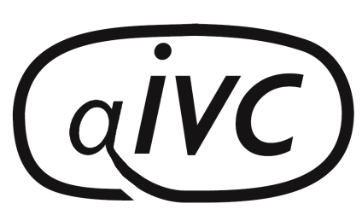

AIVC Conference 2016
9July
Cambridge
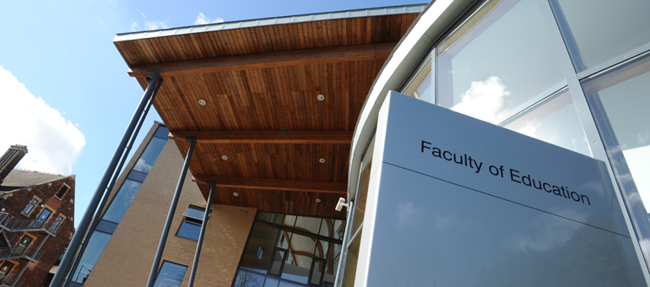
Celebrating 70 years of IVC
Faculty of Education
Hills Road
Cambridge, CB2 8PQ
Tel 01223 767600
https://www.educ.cam.ac.uk/

As you may be aware the format for the 2016 conference has changed and this year we are having a one day conference, with all business taking place on Saturday 9th July. Each club can send up to 2 delegates for the conference, for which there will be no charge, as the conference cost will be covered by AIVC. Booking is essential so that the correct number of delegates can be catered for.
A dinner/dance will be held Saturday evening, at Homerton College, next door to the Faculty of Education and AIVC will provide a £20 subsidy for conference delegates (again limited to a maximum of 2 per club). There is a booking form below for the dinner/dance, including menu choices.
This year delegates and guests will be required to book their own accommodation. Details of different venues are provided including rooms at Homerton College, where a number of rooms have been reserved for AIVC.
Any queries can be directed to:
Brenda Field chair@cambsivc.org or Ann Waterman ann22waterman@hotmail.com

BOOKING FORM

Please complete the booking form and email a copy to Brenda Field chair@cambsivc.org and Sarah Davis sarah_l_davis@talk21.com

It would be appreciated if you could confirm your booking by Mon 13th June 2016

Club Name |  | Address
Contact Name
Contact Committee Position held
Contact Phone No |  | Email

AIVC will pay for up to 2 delegates per club, to attend the AGM, at The Faculty of Education. Any additional members, who wish to attend the AGM should register as extra delegates at a cost of £18 pp. Club members who wish to attend just for the social part of the weekend should register as guests. There will be no charge if not attending the AGM. Numbers will help with organising activities.

Delegates Details
Name | Contact email | Contact Phone Number
Please let us know if you have any special dietary requirements for lunch.

Non-Delegates / Guest Details
Name | Non- Delegate (£18)  Guests FOC | Contact email | Contact Phone Number

Payments for Extra Delegates, £18 pp, and for the Saturday night dinner/dance at Homerton £44pp (£24pp for delegates), should be made by bank transfer to:

Acc Name: ASSOCIATION OF INTER-VARSITY CLUBS
Sort Code: 40-17-14
Acc No: 12392194
Ref: Your name + Conf

Or by cheque made payable to: ASSOCIATION OF INTER-VARSITY CLUBS
and sent to Sarah Davis 22 Button End, Harston, Cambridge, CB22 7NX

Saturday Dinner/Dance Homerton College Cost £44 / Delegates £24
Name | Starter | Main | Dessert
Specific dietary requirements

HOMERTON DINNER/DANCE MENU

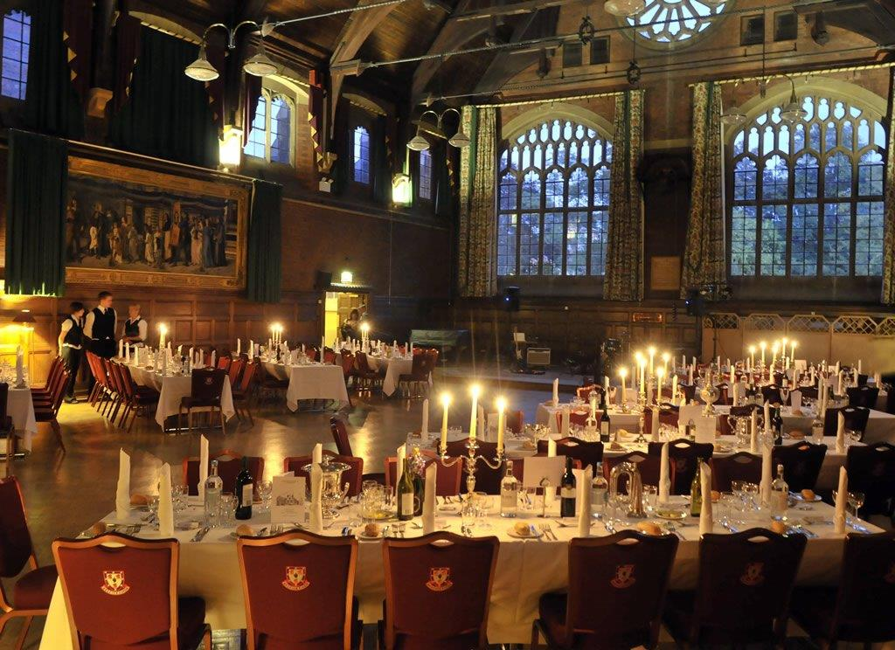
Starters
Salmon mi cuit, pickled beets, lime dressing (S1)
Camembert fig and shallot tart with a sesame seed dressing (S2)
Watercress soup, poached free range egg, garnished with toasted almonds (S3)
Main Courses
Fillet of beef from the castle estate in Lincolnshire, fondant potatoes, green beans, vine tomatoes (M1)
Pan-seared fillet of seabass, marinated peppers, crushed new potatoes, pea puree & crispy skin (M2)
Wild mushroom & spinach wellington (M3)
Desserts
Chocolate marquise, chocolate soil, white chocolate mallow & kirsch-infused cherries (D1)
Cambridge burnt cream, pistachio shortbread, raspberry sorbet (D2)
Pimms jelly, gin & tonic ice cream, orange tuille (D3)

Please let us know if you have any specific dietary requirements
ACCOMMODATION INFORMATION

Please note that prices may vary from those given here, so please check the relevant websites for up to date information on costs, availability and booking.

Venue | Accommodation & Cost per night
Homerton College  Hills Road, Cambridge, CB2 8PH  Tel 01223 747111  http://www.homertonconference.com/accommodation/  Please use the promotional code KX22741 when booking | Single £81.90
Helen Hotel  Fully Booked  167-169 Hills Rd, Cambridge CB2 8RJ  Tel 01223 246465  http://www.helenhotel.co.uk/index.htm | Single £62.00  Double £89.00
Cambridge Youth Hostel  97 Tenison Road, Cambridge, CB1 2DN  Tel 0845 371 9728  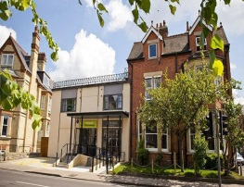  http://www.yha.org.uk/hostel/cambridge | From £23 pp
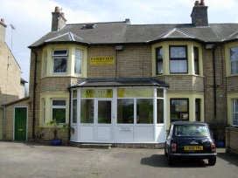  Parkview Guest House  116 Vinery Road, Cambridge, CB1 3DT  Tel 01223 247287  http://www.parkviewhotel.co.uk/ | Single £45  Double/Twin £65
Fairways Guest House  141-143 Cherry Hinton Road, Cambridge, CB1 7BX  Tel 01223 246063  http://www.fairwaysguesthouse.com/ | Single £35-£55  Double/Twin £55-£80
Railway Lodge,  150 Tennison Road, Cambridge, CB1 2DP  Telephone 01223 467688  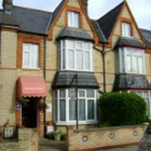  http://www.cambridge-guesthouse-accommodation.co.uk/ | Double only £85
Acacia Guest House  157 Mowbray Road, Cambridge , CB1 7SP  Tel 01223 244 300  http://www.acacia-guesthouse.co.uk/ | Single £45  Double/Twin £55-£75

Carolina Guest House  138 Perne Road, Cambridge, CB1 3NX  Tel 01223 247015  http://www.carolinaguesthouse.co.uk/ | Double £90
Travel Lodge  Cambridge Leisure Park, Clifton Way,  Cambridge, CB1 7DY  Tel 0871 984 6101  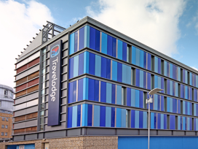  https://www.travelodge.co.uk/hotels/255/Cambridge-Central-hotel?WT.tsrc=PPC&WT.srch=1&gclid=CKyInI3bg8wCFc0y0wodvewFfw | Double £154
Centennial Hotel  63/71 Hills Road, Cambridge, CB2 1PG  Tel 01223 314652  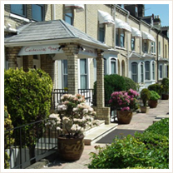  http://www.centennialhotel.co.uk/ | Single £105
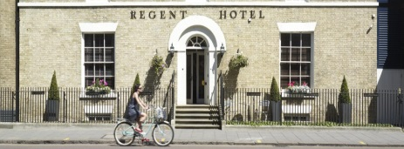  Regent Hotel  41 Regent Street, Cambridge, CB2 1AB  Tel 01223 351470  Email reservations@regenthotel.co.uk.  Book online and quote WEB for discount on flexible rate  http://www.regenthotel.co.uk | Twin/Double  £140
Royal Cambridge Hotel  Trumpington Street, CB2 1PY  Tel 01223 351631  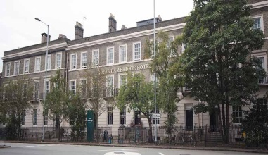  http://www.sjhotels.co.uk/cambridge | Single £159  Twin/Double £189
Gonville Hotel  Gonville Place, Cambridge, CB1 1LY  Tel 01223 366611  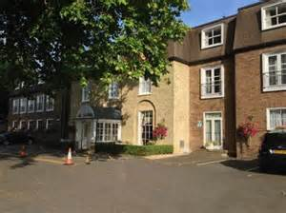  http://www.gonvillehotel.co.uk/ | From £199
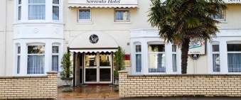  Sorrento Hotel  196 Cherry Hinton Road, Cambridge, CB1 7AN  Tel 1223 243533  http://sorrentohotelcambridge.co.uk/ | Single £85  Double from £103  Per night
The University Rooms website, provides details and booking facilities for B&B at many Cambridge University colleges. Prices and availability are variable.
http://www.universityrooms.com/en/city/cambridge/home

