# graphic 1



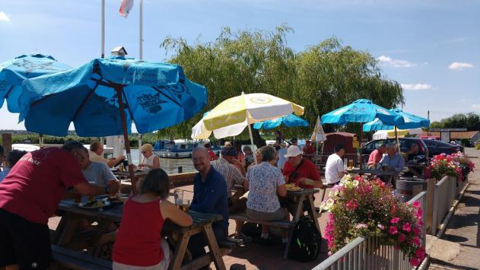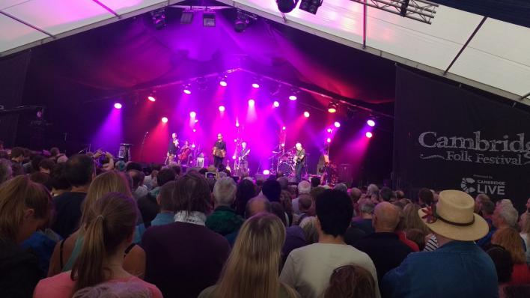

All IVC clubs belong to a national network of clubs, the Association of IVCs or AIVC, with over 40 clubs across the UK belonging to AIVC.

Each club is run independently, but being part of a national group provides opportunities to attend events run by other clubs. These are often weekends away and holidays, both in the UK and abroad. Details of shared events are published regularly and can also be found on the AIVC website [www.ivc.org.uk](http://www.ivc.org.uk).

IVC clubs have been around for a long time. The first club was started over 70 years ago by university students, to provide activities during the holidays. Today there are many clubs across the UK, with around 3000 people from all walks of life, enjoying the benefits of membership.

Meet People

Make Friends

Have Fun

MORE INFORMATION

AIVC

# IVC the club where you’ll be in very good company

For more information about Club Name please visit our website/meetup group at:

[www.?????????.?????](http://www.?????????.?????)

or phone:

12324567890

General information about IVC and details for all clubs can also be found on the national website:

[www.ivc.org.uk](http://www.ivc.org.uk)



ClubName is not just another social club. In this day of social media, where clubs come and go, we are well established.

Provide details here of how long your club has been in existence, number of members and geographical area covered.

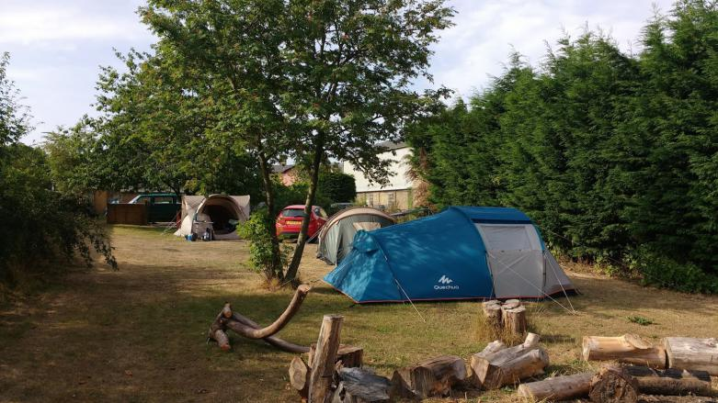

Joining your local club, also gives you access to activities organised by other clubs. Often inter-club events include days out, weekends away and even holidays abroad.



HOW IVC IS DIFFERENT TO OTHER SOCIAL CLUBS

WHAT IS IVC?



WHAT WE DO

Every month choose from the wide range of activities on offer. Some are regular events like club/pub nights, weekly bridge and badminton. Other activities may include theatre and cinema visits, walks or meals out, as well as parties, dinner dances, BBQs, bowling, dancing, festivals, days out, lectures and weekends away. Because our activities are organised by our members, we do whatever our members want and we are always open to new suggestions.

IVC is a friendly multi-activity social club for anyone, individuals or couples. It provides an opportunity to meet up with like-minded people, to make new friends and enjoy your leisure time

In a busy world, where work leaves little free time, ClubName offers you the opportunity to join in a range of activities, organised and hosted by our own members. Every month our events are publicised to members who can then choose what they would like to attend. There is always something happening, but if you fancy something different, you can arrange your own event and invite others along.

ClubName also part of a national network of IVC clubs across the UK, giving you access to even more events at home and abroad.